**Genomics in   
your practice**

## A pharmacy survey to help us support you



**Contents**

About this report 3

Section 1: Demographics 4

Number of responses and participant demographics 4

Current area of practice 5

Actively seeing patients 6

Main employer and other employers 6

Membership of specialist pharmacy groups 7

Section 2: Genomics in current and future practice 8

Confidence in genomic concepts 8

What would help improve your confidence? 9

Do you feel prepared to use genomic testing in your practice? 10

Which of these genomic tests are you aware of? 12

Awareness of genetic/genomic testing guidelines 12

Current role in ordering laboratory tests on patient samples (such as blood glucose and cholesterol) 13

Pharmacists’ current role in genetic/genomic testing 13

Future roles for pharmacists and pharmacy technicians in genomic testing 13

Anticipated changes in pharmacy practice due to genomics 14

Delivering pharmacogenomic testing in the future 15

Initiating and discussing genomic tests 15

Section 3: Education and Training 17

Formal genomics training – received and provided 17

Preferred models of delivery for future genomics training 18

Who should be responsible for updating the pharmacy team about genomics? 19

What topics does the pharmacy workforce want to learn about? 20

Appendix 1 24

Appendix 2 28

Appendix 3 33

## About this report

These results have been presented at the Pharmacy Workforce Group for Genomics and the Royal Pharmaceutical Society’s annual conference in 2023, the abstract of which is published within the *International Journal of Pharmacy Practice* ([DOI: 10.1093/ijpp/riad074.066](https://doi.org/10.1093/ijpp/riad074.066)).

The Pharmacy Genomics Workforce Survey was a collaboration between NHS England’s Genomics Education Programme (GEP) and the Central and South Genomic Medicine Service Alliance (GMSA), with the intention of surveying the pharmacy workforce across the UK about their knowledge and readiness to practice genomics-informed medicine. It was based on [a similar survey of medical professionals by the GEP in 2021/22](https://www.genomicseducation.hee.nhs.uk/documents/genomics-in-your-practice-a-health-and-social-care-survey/), with additional and specialised content agreed with GMSA pharmacists and pharmacy representatives from Scotland, Wales and Northern Ireland. Survey questions are available on request.

The survey was open between 1 March 2022 and 15 April 2022 and hosted by the GEP on the SmartSurvey platform with appropriate information governance approval. The survey link was publicised via pharmacy groups including the Royal Pharmaceutical Society, National Pharmacy Association, Local Pharmaceutical Committees, chief pharmacists’ networks and social media.

## Section 1: Demographics

### Number of responses and participant demographics

#### Total number of responses 1,551

* 1,546 UK/Isle of Man, where:
  + England/Isle of Man: 1,051 (68.0%)
  + Scotland: 197 (12.7%)
  + Northern Ireland: 163 (10.5%)
  + Wales: 135 (8.7%)
* Non-UK: 5 (these respondents are excluded from reported results)

#### England GMSA regional split

* North East and Yorkshire GMSA: 254 (24.2%)
* South East GMSA: 202 (19.2%)
* South West GMSA: 167 (15.9%)
* Central and South GMSA: 154 (14.7%)
* East GMSA: 132 (12.6%)
* North West GMSA: 89 (8.5%)
* North Thames GMSA: 52 (4.9%)
* Not specified: 1 (0.1%)

#### Role

* Pharmacist: 1,060 (68.6%)
* Pharmacy technician: 377 (24.4%)
* Pharmacy support worker/assistant/dispenser: 57 (3.6%)
* Foundation trainee pharmacist: 18 (1.2%)
* Trainee pharmacy technician: 14 (0.9%)
* Others: 20 (1.3%)

We compared some metrics per country using chi-squared (Chi2) tests. No significant differences were found between the four countries for the following variables:

* Pharmacist or trainee pharmacist (vs not)
* Pharmacy technician or trainee pharmacy technician (vs not)
* Seeing patients (vs not seeing patients)

#### Experience working in pharmacy

Responses were received from the pharmacy workforce that represented the different levels of experience within pharmacy (Figure 1), with 14.0%–17.3% of responses coming from each of the 5-year ranges from 0 years experience up to 25 years, 10% from 25–30 years, and 14% from respondents with over 30 years of experience.

Figure 1.The distribution of respondents’ years in profession or working in pharmacy.

### Current area of practice

Respondents could select more than one. Percentages are as a proportion of total number of UK responses.

* Hospital: 1,022 (66.1%); of which:
  + NHS hospital: 1,014
  + Private hospital: 8
* GP/primary care: 245 (15.8%)
* Community pharmacy: 134 (8.7%)
* Clinical commissioning group (CCG): 112 (7.2%)
* Academia/education: 90 (5.8%)
* Community Trust: 37 (2.4%)
* Public Health: 15 (1.0%)
* Intermediate care: 7 (0.5%)
* Other (including industry): 87 (5.6%)

### Actively seeing patients

1,104 out of 1,546 (71.4%) respondents see patients either in person or via the telephone/internet. Of these, 1,061 (96.1%) see adult patients and 273 (24.7%) see paediatric patients (respondents were able to select both).

### Main employer and other employers

Everyone surveyed indicated their main employer type (Table 1). 196 respondents had an additional second employer type and 23 had a third employer type.

Table 1. Showing respondents’ main employer types, and the total working for each employer type for some or all of their time.

|  |  |  |  |  |
| --- | --- | --- | --- | --- |
| **Employer type** | **Main employer** | | **Respondents working for this employer type for some or all of their time** | |
| NHS hospital or healthcare provider | 1,143 | (73.9%) | 1,161 | (75.1%) |
| Primary care network/GP | 140 | (9.1%) | 159 | (10.3%) |
| Clinical commissioning group (CCG) | 98 | (6.3%) | 111 | (7.2%) |
| Community pharmacy, large employer (≥100 pharmacies) | 38 | (2.5%) | 61 | (3.9%) |
| University or education provider | 26 | (1.7%) | 78 | (5.0%) |
| Community pharmacy, small/independent (1–5 pharmacies) | 21 | (1.4%) | 37 | (2.4%) |
| Community pharmacy, medium employer (6–99 pharmacies) | 14 | (0.9%) | 18 | (1.2%) |
| Self-employed/private practice | 12 | (0.8%) | 57 | (3.7%) |
| Arm's length body (for example, Health Education England, NHS Education for Scotland, Health Education and Improvement Wales) | 11 | (0.7%) | 28 | (1.8%) |
| Private hospital or healthcare provider | 11 | (0.7%) | 23 | (1.5%) |
| Other | 32 | (2.1%) | 73 | (4.7%) |

### Membership of specialist pharmacy groups

Participants reported membership of a wide range of professional organisations. As well as those listed in Table 2, there were 182 additional responses (list available on request). Of note, nearly one-third of applicants did not belong to any pharmacy groups. This may be relevant when targeting/publicising training opportunities.

Table 2. Showing which pharmacy professional organisations respondents are members of.

|  |  |
| --- | --- |
| **Organisation** | **Number of respondents** |
| Royal Pharmaceutical Society | 552 (35.7%) |
| Specialist Pharmacy Service | 288 (18.6%) |
| UK Clinical Pharmacy Association | 226 (14.6%) |
| Association of Pharmacy Technicians UK | 166 (10.7%) |
| British Oncology Pharmacy Association | 117 (7.6%) |
| Primary Care Pharmacy Association | 112 (7.2%) |
| National Pharmacy Association | 32 (2.1%) |
| UK Clinical Pharmacy Association Genomics community | 8 (0.5%) |
| I don’t belong to any pharmacy groups | 480 (31.0%) |
| Other | 182 (11.8%) |

## Section 2: Genomics in current and future practice

### Confidence in genomic concepts

Respondents were asked to select a number from a scale of 1 to 10, where 1 was ‘not at all confident’ and 10 was ‘very confident’, to indicate how they felt with various genomic concepts and related activities. Respondents could state that they were ‘unsure how confident I am’; these respondents were excluded from this analysis.

This analysis focuses on just pharmacists and pharmacy technicians, as they had the largest number of respondents; therefore, general conclusions may be drawn. Although there are no significant differences between pharmacists and pharmacy technicians (Chi2 p>0.05 for all questions), generally pharmacists reported being slightly more confident when compared with pharmacy technicians. Despite this, it is clear the professions overall are not confident.

Figure 2 shows the distribution for confidence in knowledge about genomics, but all confidence questions resulted in similar distributions (see Appendix 1 for all distributions).

Figure 2. Distribution of responses from pharmacists and pharmacy technicians when asked ‘How confident are you in your knowledge about genomics?’

### What would help improve your confidence?

850 pharmacists and pharmacy technicians answered this question.

* 727 (85.5%) gave a response related to training/education, such as:
  + 73 specified online training;
  + 40 specified that training/education should be role/area specific;
  + 26 specified webinars;
  + 23 specified case studies;
  + 21 specified basic training;
  + 20 specified reading;
  + 19 specified continuous professional development (CPD);
  + 13 specified courses from the Centre for Pharmacy Postgraduate Education (CPPE);
  + 9 specified that training/education should be accredited;
  + 7 specified in-person training/education or explicitly said “not online”; and
  + 3 mentioned funding for training/education.
* 55 (6.5%) stated a need for more information.
* 54 (6.4%) mentioned that doing things in practice would help, with many indicating that at the moment it was ‘theoretical’.
* 22 (2.6%) said they didn’t know where to find resources.
* 21 (2.5%) mentioned having access to a specialist would help, such as to ask questions to, shadow or work with.
* 17 (2.0%) mentioned the need for guidance/guidelines.
* 4 (0.5%) mentioned the need for study leave/time.

Respondents had to opportunity to leave a comment. Some quotes are provided below.

“Real case studies of routine use of genomics – I understand the principle but still feels a bit removed from common practice, maybe even a bit sci-fi!”

“APTUK online training.”

“Proper training with certification – not online training or e-learning, which seems to be transient.”

“Some training, especially as this has been added to an element of one of the new GPhC Learning Outcomes for foundation-year trainee pharmacists, of which I am the lead tutor for and feel it has been added in with no explanation!”

“Involvement in areas of the country regarding whether genomics will be available to guide healthcare (i.e. district generals may have less funding available for this compared to teaching hospitals).”

### Do you feel prepared to use genomic testing in your practice?

Table 3 shows that only 8.2% of pharmacists and 1.1% of pharmacy technicians felt prepared to use genomic testing in their practice. Of the remainder of pharmacists and pharmacy technicians, 15.6% of all respondents reported feeling unsure and 78.1% stated that they did not feel confident to use genomic testing in their practice.

Table 3. Showing the numbers and percentages of pharmacists and pharmacy technicians who feel prepared to use genomic testing in their practice.

|  |  |  |  |  |  |  |
| --- | --- | --- | --- | --- | --- | --- |
| **Prepared to use genomics** | **Pharmacists** | | **Pharmacy technicians** | | **Total** | |
| Yes | 87 | (8.2%) | 4 | (1.1%) | 91 | (6.4%) |
| No | 803 | (76.0%) | 315 | (84.0%) | 1,118 | (78.1%) |
| Unsure | 167 | (15.8%) | 56 | (14.9%) | 223 | (15.6%) |
| Total | 1,057 |  | 375 |  | 1,432 |  |

Below are some responses from those who indicated they do not feel prepared to use genomic testing in their practice.

“Genomic testing was not taught in university and the expectation to be prepared for it is farcical. It is train crash in the making with significant patient harm in the horizon.”

“I don't know what it would require from me; I thought this area was very specialist and wouldn't be relevant to primary care.”

“I am interested to learn more on this area if I was expected to consult with patients on genomic testing and their treatment.”

“I have attended informative training sessions previously (approx. 3 years ago) that made a lot of sense at the time, but as I was not actively involved/using the information I feel I have not retained this. Other competing priorities e.g. Covid vaccination, CVD, AMS have taken my time. In order to be prepared I feel I need to see real-life examples of how it is being used in my day-to-day practice to encourage me to complete relevant CPD and learning and retain this learning.”

“I have not had any opportunities to find out more or seen any leaning resources.”

“I have not yet had any training in this area other than a brief introduction to the subject as part of my pharmacy technician training course.”

“I have received no training in this subject area. Also, it is an area I do not feel any colleagues or the MDT is really that aware of either.”

“I have the basic understanding of genomic principles but no knowledge of how this is practicable within the NHS, how to talk to patients about what is available and how to do this in practice. I am involved in commissioning and having an understanding of this would be vital for commissioning pharmacogenomic services in future.”

“It is not something I am familiar with at all. I would need teaching and training to incorporate it into my practise. Maybe a person who was a genomics champion in the department to help.”

“It is very specific to certain area and is gradually becoming more common, but only the specialists are knowledgeable enough to deal with questions from patients etc. Unlike other medicines where, as a pharmacist, I can answer questions about a patient's stroke medicines on a surgical ward.”

“Lack of NHS guidelines, protocols and standard operating procedures.”

“More training e.g. as part of NES post registration foundation training programme.”

“My current practice is in education and training, so it has not been a factor”

“Need access to training – applied for a standalone module with Exeter and it required my line manager to explain how I would use the course in practice in order to get funding. Well, I work in a DGH without genomic technology so I will never use it!”

“Needs to be better established with a firm evidence base and economic evaluation for routine use – I don't think we are there yet.”

“No, and don't see a real need as the only genetic testing available for MH that I am aware of is clozapine, which is currently not reliable enough for use in the NHS at present. If/when this changes, I will ensure I learn what I need to.”

“To my knowledge I have no involvement with genomics in my current role. I suspect I would need to significantly enhance my knowledge in the area if my role were to include some of the activities above.”

“Until the testing is available more widely in the NHS, then there are so many other issues that I need to be updated on that it is not going to be a priority. I always like to be prepared, and up to date, I don't think I am, but there wouldn't need to be too much additional training as the principles are familiar to us as a profession I think, we just don't use it day to day.”

“We have received no information from our trust regarding any advances in implementation, it is not within the trust pharmacy strategy. There seems to be a lack of engagement in the South East with only one trust, St George's, having a pharmacy genomics infrastructure.”

### Which of these genomic tests are you aware of?

Respondents were provided with a list of genomic tests and asked which they were aware of (see Figure 3). Some of the tests were currently available in the NHS and others were not.

In general, fewer pharmacy technicians than pharmacists were aware of the named tests; but even the most commonly recognised tests among the pharmacist cohort, *BRCA* testing and familial hypercholesterolaemia, were recognised by under 60% of pharmacists (55.6% and 53.4% respectively).

Figure 3. The genomic tests that pharmacists, pharmacy technicians and all other survey respondents stated that they are aware of.

### Awareness of genetic/genomic testing guidelines

Participants were asked if they were aware of any genetic and/or genomic testing guidelines, either local, national or international, that were used for their patients. 21.2% of pharmacists (n=225) and 4.2% of pharmacy technicians (n=16) were aware of such guidelines. These respondents were able to name international (Clinical Pharmacogenetics Implementation Consortium or Dutch Pharmacogenetics Working Group), national (All Wales Genomics Service guidance or UK Systemic Anti-Cancer Therapy Board guidelines) or local primary/secondary care guidelines.

### Current role in ordering laboratory tests on patient samples (such as blood glucose and cholesterol)

All 1,546 respondents answered this question. There is a significant difference (Chi2 =103.4, p<0.01) between pharmacists and pharmacy technicians in ordering tests: 40.3% (n=427) of pharmacists and 12.2% (n=46) of pharmacy technicians reported that they currently ordered laboratory tests on patient samples (for example, sending routine blood tests). Conversely, 57.7% (n=612) of pharmacists and 87.5% (n=330) of pharmacy technicians said that they did not currently order laboratory tests on patient samples.

The remaining respondents gave individual free text responses, which most commonly involved recommending testing rather than directly ordering tests themselves.

### Pharmacists’ current role in genetic/genomic testing

Pharmacists were asked if they personally had ordered a genetic test for a patient: 29 (2.7%) reported that they had from across England, Wales, Scotland and Northern Ireland.

113 (10.7%) pharmacists reported attending a multidisciplinary team meeting that discussed genetic test results and 44 (4.2%) reported having discussed genetic test results with patients.

48 (4.5%) pharmacists had contacted their local clinical genetics service in the last 12 months, while 5 (0.5%) pharmacists were uncertain if they had contacted their local clinical genetics service in the last 12 months. Three pharmacists did not answer this question. Of the 1,004 pharmacists who had not contacted their clinical genetics service, the reasons selected were (respondents could select more than one option):

* not having needed their advice: 592 (59.0%);
* not knowing how to contact them: 425 (42.3%);
* not being sure what they do: 369 (36.8%);
* ‘Genetics and genomics is not relevant to my practice’: 317 (31.6%);
* not having access to a genetics service: 264 (26.3%); and
* ‘I can manage my patients without advice from a clinical genetics service’: 85 (8.5%).

### Future roles for pharmacists and pharmacy technicians in genomic testing

All participants who had not personally ordered a genetic test for a patient were asked if they could ever envisage ordering, advising on or counselling patients on genetic or genomic testing in the future, potentially after receiving appropriate education and training.

Overall, 66.0% (n=1,001) of respondents who had not previously ordered a genetic test agreed that they could envisage ordering, advising on or counselling patients on genetic/genomic testing in the future. This represented 70.8% (n=730) of pharmacists and 56.2% (n=212) of pharmacy technicians who had not previously ordered a genetic test.

### Anticipated changes in pharmacy practice due to genomics

68.9% (n=730) of pharmacists and 52.8% (n=199) of pharmacy technicians thought that genomics would change their practice in the next five years. Of those who anticipated a change in their practice, the following changes were anticipated:

* selection and dosage of medications: 95.3% (n=696) of pharmacists and 81.9% (n=163) of pharmacy technicians;
* changes in patient diagnosis: 73.8% (n=539) of pharmacists and 72.9% (n=145) of pharmacy technicians;
* the type of patient work they were doing would change due to genomics, for example using variant interpretation to choose a therapy: 24.0% (n=175) of pharmacists and 28.6% (n=57) of pharmacy technicians;
* their workload would increase due to genomics: 34.9% (n=255) of pharmacists and 29.1% (n=58) of pharmacy technicians; and
* their workload would decrease due to genomics: less than 1% overall thought this.

Among those who thought that genomics would not change their practice in the next five years, reasons given are included below.

“Hospital setting and is above technician level.”

“I plan to retire at the end of this year!!!”

“My Trust isn't a tertiary centre.”

“I feel that this is something that has not even been discussed where I work.”

“This was all the buzz when I first qualified; but 20 years later, there has been no changes in gene therapy for cancer treatment within the trust.”

“Because I work in a prison. Prison healthcare is focused primarily on managing acute and chronic medical conditions, and mental health services. I'm aware that patients are routinely tested for BBV and sexual health conditions, but not sure funding would allow services to extend to genomics also? I would definitely be interested in learning more about it though if we did offer this service.”

“At present, there does not seem to be development of this in my group of patients – community and mental health.”

“Working in A&E. Genomics is less likely to be applicable in the emergency care setting (though I might be completely wrong).”

“I work in A&E where there are very medicines where genomics would impact on choice and even with genomic testing results would not be received quickly enough to inform clinical decision making. It's not a priority in Emergency Medicine.”

“Currently, its applicability on an acute ward seems minimal.”

### Delivering pharmacogenomic testing in the future

Pharmacists were asked for their opinions and views on potential models for delivering pharmacogenomic testing, assuming they had received appropriate training. Five potential pathways were suggested and respondents asked to select their first preference, which are listed here from most to least popular.

* You initiate testing and discuss results with patients/families/prescribers with support from a clinical genetics team as needed: 273 (25.8%)
* You refer to a clinical genetics team to initiate testing, and discuss results with patients/families/prescribers: 189 (17.8%)
* You help with interpretation of test results and discuss results with patients/families/prescribers, but do not initiate testing or refer for this: 177 (16.7%)
* You do not see, and do not expect to see, patients who would benefit from pharmacogenomic testing: 82 (7.7%)
* You initiate testing and discuss results with patients/families/prescribers: 29 (2.7%)
* Unsure at this stage: 292 (27.5%)

### Initiating and discussing genomic tests

Participants were presented with a list of ways that genomic tests can be initiated and discussed with patients by pharmacists and pharmacy technicians, and asked to indicate which currently occur in their practice and/or they believed will occur more frequently in the next five years. 1,057 pharmacists and 375 pharmacy technicians answered this section. When looking at responses from pharmacists and pharmacy technicians separately, pharmacy technicians were more likely to reply ‘unsure’, but the pattern of responses was similar with these responses removed. These cohorts’ responses are combined and shown in Figure 4, with all data provided in Appendix 2.

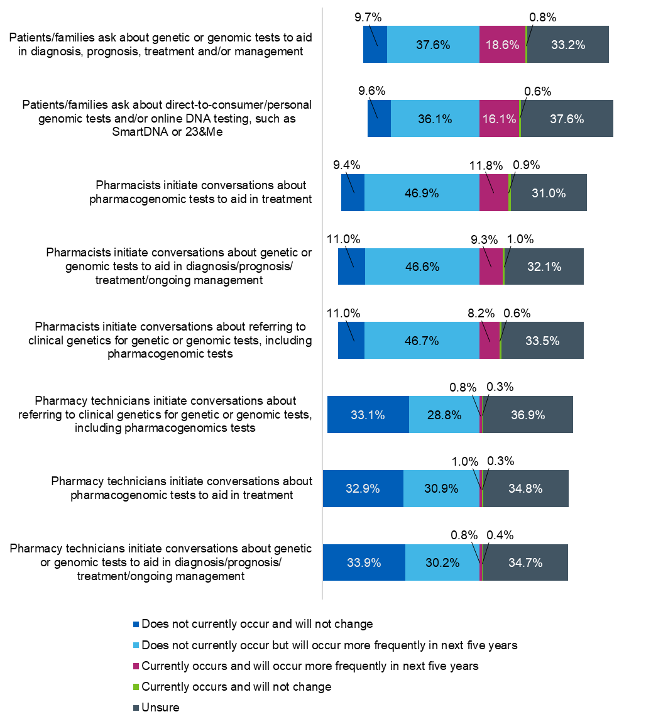

Figure 4. Respondents were asked which ways of initiating tests by pharmacists and pharmacy technicians currently occur and which do not, as well as if they thought that each is likely to occur more frequently in the next five years.

## Section 3: Education and Training

### Formal genomics training – received and provided

Of 762 respondents, 87.3% (n=665) said that they had received no formal university-level teaching in genomics (77.9%, n=215 of pharmacists and 96.6%, n=364 of pharmacy technicians).

Those who responded that they had received formal teaching (n=97, 12.3%) were asked to further describe this. Some respondents had received more than one type of training, therefore there were a total of 104 responses:

* As part of my pharmacy degree or pharmacy technician training: 68
* A Master’s module or similar: 8
* Master’s in Genomics Medicine: 6
* PGDip Genomic Medicine: 1
* Training associated with my employment (such as ‘learning at lunch’ or study days): 1
* Other: 20

‘Other’ training included BSc/BA/MSc/MRes/MPhil in related subjects, such as biology, biochemistry, biotechnology, genetics, health sciences, microbiology and the Exeter MODY course.

14.3% of respondents (n=109) had attended professional development, education or training sessions around genomics in the last three years, such as lectures, seminars or workshops, either in person or online.

These respondents were then asked about this training. Around a quarter (24.8%, n=27) reported that the sessions had been in-house (internal) training programmes, a further quarter (24.8%, n=27) indicated they were external training programmes and over half (54.1%, n=59) indicated they had attended online training (for example, webinars or massive open online courses (MOOCs)).

1.8% of respondents (n=14) reported providing professional development or education or training sessions around genomics in the last three years. Most of these (n=10) taught within an in-house programme, with 3 teaching on an external programme and 2 providing online training.

### Preferred models of delivery for future genomics training

All 1,546 respondents answered this question, with 97.0% (n=1,500) indicating interest in future training. Those who were interested in future training were asked how they would prefer to receive training. They could select multiple delivery methods. The results were:

* Blended learning (mixture of in-person and online training): 488 (32.5%)
* Online training – pre-recorded lectures/self-led activities: 388 (25.9%)
* Online training – delivered 'live': 373 (24.9%)
* In-person training: 347 (23.1%)
* Self-directed learning: 257 (17.1%)

Of those interested in future training, 285 (19.0%) were interested studying for a formal qualification in genomics. Of these, they were interested in (multiple responses could be selected):

* PGCert/Dip Genomic Medicine: 238 (83.5%)
* Master’s in Genomic Medicine: 129 (45.3%)
* PhD Genomic Medicine: 73 (25.6%)

Separately, of those interested in future training, 319 (21.3%) said they would be interested in studying a module or modules from the Master’s in Genomic Medicine, while 299 (19.9%) were not interested in studying for a formal qualification in genomics.

### Who should be responsible for updating the pharmacy team about genomics?

All 1,546 respondents answered this question, see Figure 5. The most popular option was professional education providers, such as the Genomics Education Programme (31.5%, n=487), followed by the Royal Pharmaceutical Society (25.5%, n=394), genomics specialist pharmacists (24.7%, n=382) and medical colleges/schools of pharmacy (24.7%, n=382). ‘Other’ providers suggested included CPPE, NHS Education for Scotland, Northern Ireland Centre for Pharmacy Learning and Development, Association of Pharmacy Technicians UK and NHS England.

Figure 5. Responses to the question: ‘Who should educate pharmacy teams about genomics?’

### What topics does the pharmacy workforce want to learn about?

All participants were asked a general set of questions about what topics they would be interested to learn more about. This was the last section of the survey and a considerable number of respondents exited the survey at this point. 716 answered this section, which included 273 pharmacists and 350 pharmacy technicians.

Both pharmacists and pharmacy technicians were keen to learn more about topics they had and had not learnt about before (Figures 6 and 7). Pharmacy technicians were less likely to have had previously learnt about one of the genomics topics provided, but were similarly enthusiastic about learning more, regardless of whether they had previously encountered the topic before.

270 pharmacists responded to an additional and more detailed set of queries about genomics topics they have learnt about and would/would not like to learn more about (Figures 8 and 9). As the terms became more specific, respondents were less likely to have learnt about those topics but were overwhelmingly keen to learn more about all topics. Numerical data is available in tables in Appendix 3.

Figure 6. The general genomics topics that pharmacists have learnt about and would like to learn more about.

Figure 7. The general genomics topics that pharmacy technicians have learnt about and would like to learn more about.

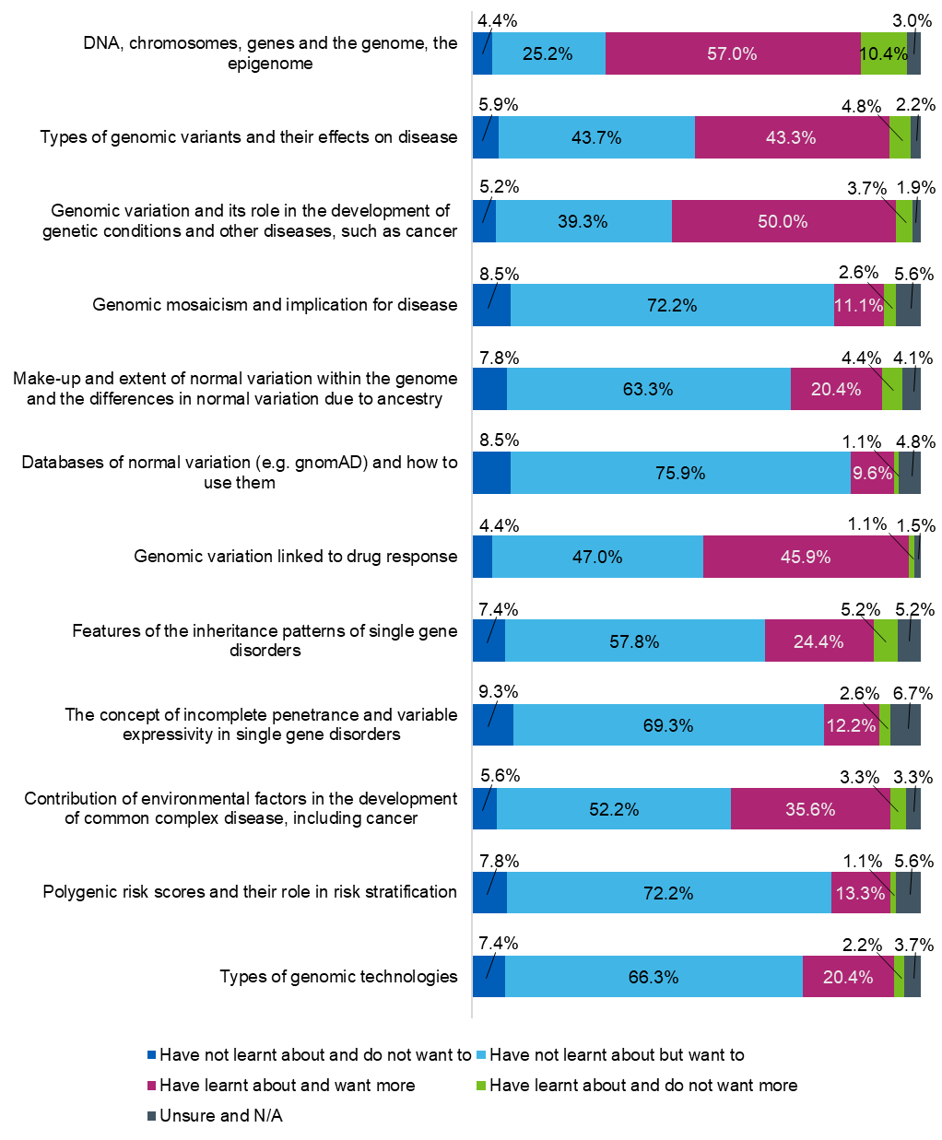

Figure 8. Fundamental principles in genomics that pharmacists have learnt about, and would be interested to learn more about in the future

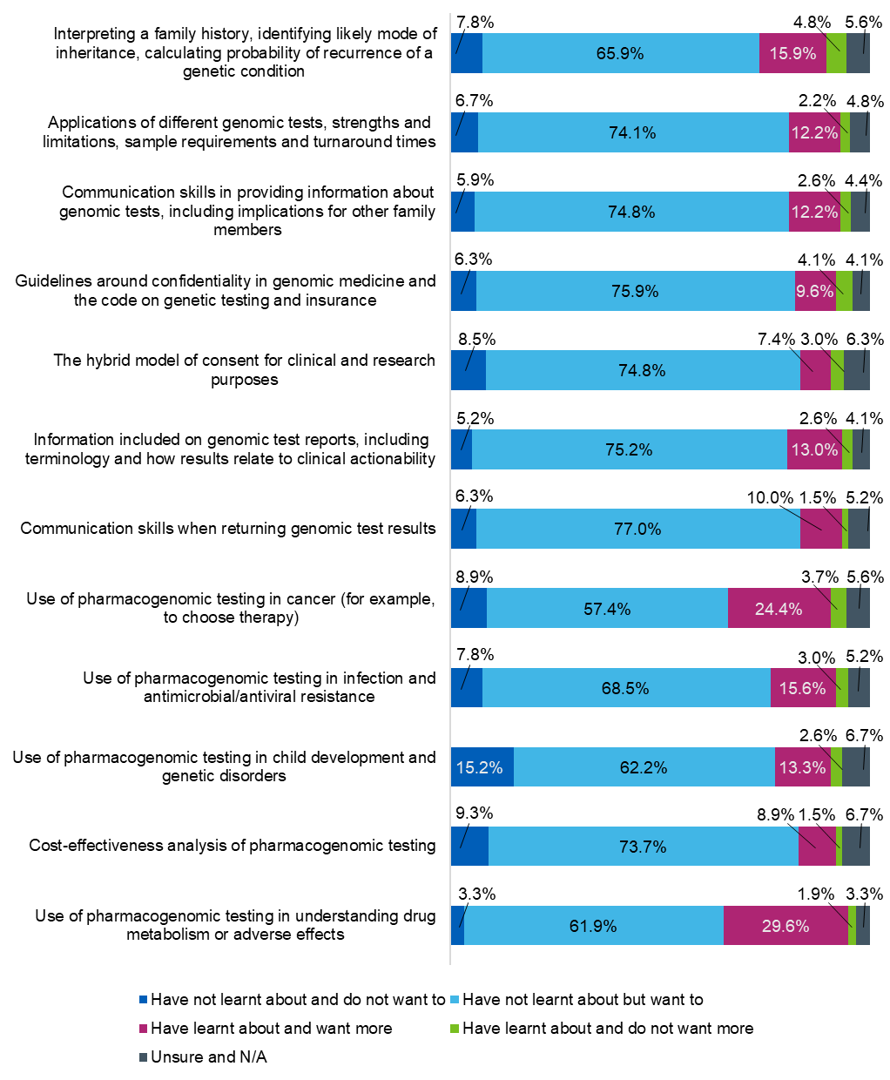

Figure 9. Applications of genomic medicine that pharmacists have learnt about, and would be interested to learn more about in the future.

## Appendix 1

#### Confidence in genomic concepts

Figure 10. Distribution of responses from pharmacists and pharmacy technicians when asked: ‘How confident are you in your ability to access information about genomic testing?’

Figure 11. Distribution of responses from pharmacists and pharmacy technicians when asked: ‘How confident are you in your ability to discuss general principles of genomic testing with patients/families?’

Figure 12. Distribution of responses from pharmacists and pharmacy technicians when asked: ‘How confident are you in your knowledge about facilitating patient informed consent for genomic testing (for example, risks and benefits, incidental findings, impact on families)?’

Figure 13. Distribution of responses from pharmacists and pharmacy technicians when asked: ‘How confident are you in your ability to explain genomic concepts to patients?’

Figure 14. Distribution of responses from pharmacists and pharmacy technicians when asked: ‘How confident are you in your ability to make decisions based on genomic information?’

Figure 15. Distribution of responses from pharmacists and pharmacy technicians when asked: ‘How confident are you in your ability to select the right genomic tests for patients?’

Figure 16. Distribution of responses from pharmacists and pharmacy technicians when asked: ‘How confident are you in your ability to discuss the impact of specific genetic variation on drug selection and dosing with prescribers (pharmacogenomics)?’

## Appendix 2

#### Initiating and discussing genomic tests

Table 4. Data for Figure 4

|  |  |  |  |  |  |
| --- | --- | --- | --- | --- | --- |
| **All respondents** | Does not currently occur  and will not change | Does not currently occur but will occur more frequently in next five years | Currently occurs and will occur more frequently in  next five years | Currently occurs and  will not change | Unsure |
| Patients/families ask about genetic or genomic tests to aid in diagnosis, prognosis, treatment and/or management | 9.7% (n=139) | 37.6%  (n=539) | 18.6%  (n=266) | 0.8% (n=12) | 33.2%  (n=476) |
| Patients/families ask about direct-to-consumer/personal genomic tests and/or online DNA testing, such as SmartDNA or 23&Me | 9.5% (n=137) | 36.1%  (n=517) | 16.1% (n=231) | 0.6% (n=9) | 37.6%  (n=538) |
| Pharmacists initiate conversations about pharmacogenomic tests to aid in treatment | 9.4% (n=134) | 46.9%  (n=672) | 11.8% (n=169) | 0.9% (n=13) | 31.0%  (n=444) |
| Pharmacists initiate conversations about genetic or genomic tests to aid in diagnosis/prognosis/ treatment/ongoing management | 11.0% (n=158) | 46.6%  (n=668) | 9.3% (n=133) | 1.0% (n=14) | 32.1%  (n=459) |
| Pharmacists initiate conversations about referring to clinical genetics for genetic or genomic tests, including pharmacogenomic tests | 11.0% (n=157) | 46.7%  (n=669) | 8.2% (n=117) | 0.6% (n=9) | 33.5%  (n=480) |
| Pharmacy technicians initiate conversations about referring to clinical genetics for genetic or genomic tests, including pharmacogenomics tests | 33.1%  (n=474) | 28.8%  (n=412) | 0.8% (n=12) | 0.3% (n=5) | 36.9%  (n=529) |
| Pharmacy technicians initiate conversations about pharmacogenomic tests to aid in treatment | 32.9%  (n=471) | 30.9%  (n=443) | 1.0% (n=15) | 0.3% (n=5) | 34.8%  (n=498) |
| Pharmacy technicians initiate conversations about genetic or genomic tests to aid in diagnosis/prognosis/treatment/ongoing management | 33.9%  (n=485) | 30.2%  (n=432) | 0.8% (n=12) | 0.4% (n=6) | 34.7%  (n=497) |

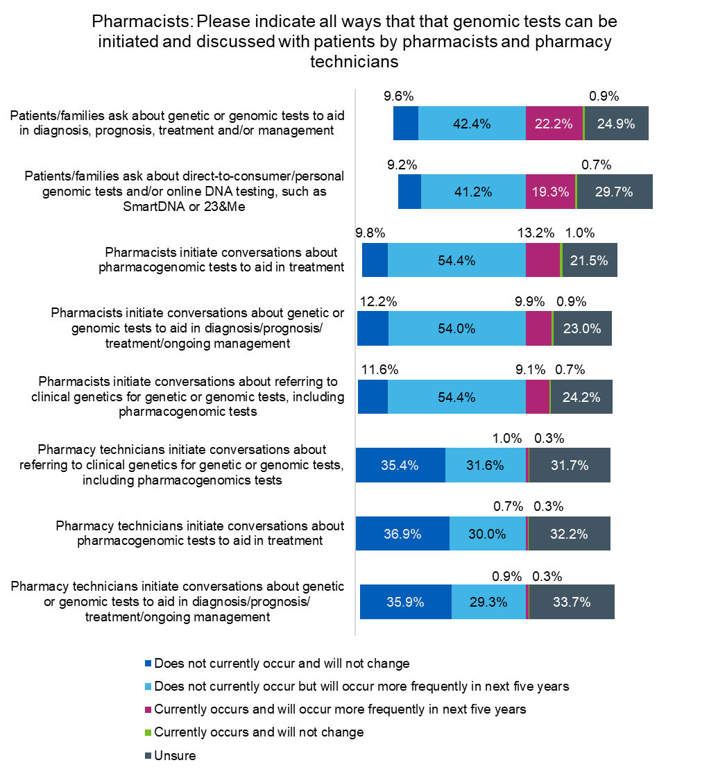

Figure 17. Pharmacists were asked which ways of initiating tests by pharmacists and pharmacy technicians currently occur and which do not, as well as if they thought that each is likely to occur more frequently in the next five years.

Table 5. Data for Figure 17

|  |  |  |  |  |  |
| --- | --- | --- | --- | --- | --- |
| **Pharmacists** | Does not currently occur  and will not change | Does not currently occur but will occur more frequently  in next five years | Currently occurs and will occur more frequently  in next five years | Currently occurs and  will not change | Unsure |
| Patients/families ask about genetic or genomic tests to aid in diagnosis, prognosis, treatment and/or management | 9.6% (n=102) | 42.4%  (n=448) | 22.2%  (n=235) | 0.9% (n=9) | 24.9%  (n=263) |
| Patients/families ask about direct-to-consumer/personal genomic tests and/or online DNA testing, such as SmartDNA or 23&Me | 9.2% (n=97) | 41.2%  (n=435) | 19.3%  (n=204) | 0.7% (n=7) | 29.7%  (n=314) |
| Pharmacists initiate conversations about pharmacogenomic tests to aid in treatment | 9.8% (n=104) | 54.4%  (n=575) | 13.2% (n=140) | 1.0% (n=11) | 21.5%  (n=227) |
| Pharmacists initiate conversations about genetic or genomic tests to aid in diagnosis/prognosis/ treatment/ongoing management | 12.2% (n=129) | 54.0%  (n=571) | 9.9% (n=105) | 0.9% (n=9) | 23.0%  (n=243) |
| Pharmacists initiate conversations about referring to clinical genetics for genetic or genomic tests, including pharmacogenomic tests | 11.6 % (n=123) | 54.4%  (n=575) | 9.1% (n=96) | 0.7% (n=7) | 24.2%  (n=256) |
| Pharmacy technicians initiate conversations about referring to clinical genetics for genetic or genomic tests, including pharmacogenomics tests | 35.4%  (n=374) | 31.6%  (n=334) | 1.0% (n=11) | 0.3% (n=3) | 31.7%  (n=335) |
| Pharmacy technicians initiate conversations about pharmacogenomic tests to aid in treatment | 36.9%  (n=390) | 30.0%  (n=317) | 0.7% (n=7) | 0.3% (n=3) | 32.2%  (n=340) |
| Pharmacy technicians initiate conversations about genetic or genomic tests to aid in diagnosis/prognosis/ treatment/ongoing management | 35.9%  (n=379) | 29.3%  (n=310) | 0.9% (n=9) | 0.3% (n=3) | 33.7%  (n=356) |

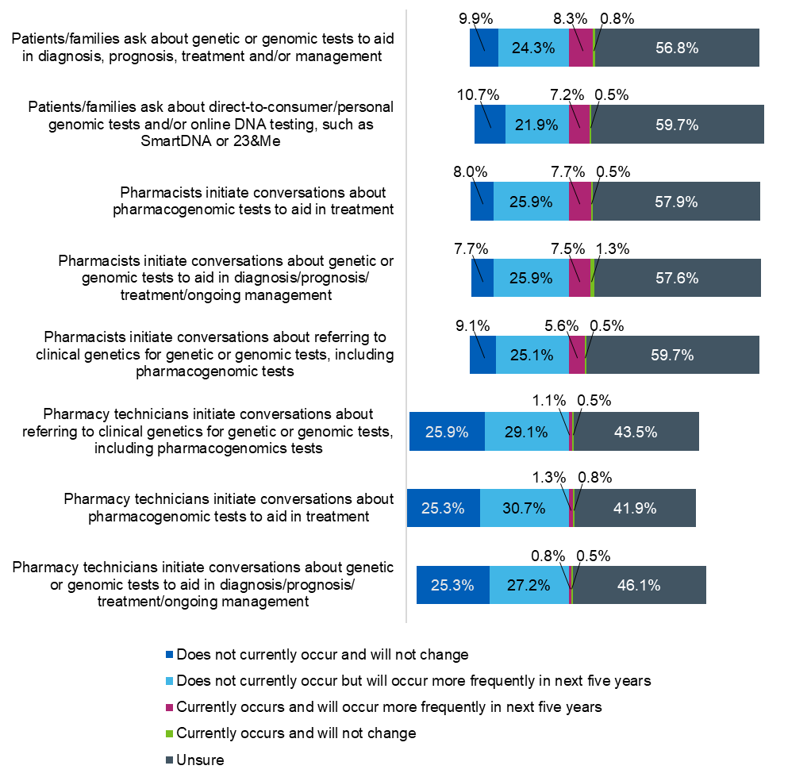

Figure 18. Pharmacy technicians were asked which ways of initiating tests by pharmacists and pharmacy technicians currently occur and which do not, as well as if they thought that each is likely to occur more frequently in the next five years.

Table 6. Data for Figure 18.

|  |  |  |  |  |  |
| --- | --- | --- | --- | --- | --- |
| **Pharmacy technicians** | Does not currently occur  and will not change | Does not currently occur but will occur more frequently in next five years | Currently occurs and will occur more frequently in  next five years | Currently occurs and  will not change | Unsure |
| Patients/families ask about genetic or genomic tests to aid in diagnosis, prognosis, treatment and/or management | 9.9% (n=37) | 24.3%  (n=91) | 8.3% (n=31) | 0.8% (n=3) | 56.85  (n=213) |
| Patients/families ask about direct-to-consumer/personal genomic tests and/or online DNA testing, such as SmartDNA or 23&Me | 10.7% (n=40) | 21.9%  (n=82) | 7.2% (n=27) | 0.5% (n=2) | 59.7%  (n=224) |
| Pharmacists initiate conversations about pharmacogenomic tests to aid in treatment | 8.0% (n=30) | 25.9%  (n=97) | 7.7% (n=29) | 0.5% (n=2) | 57.9%  (n=217) |
| Pharmacists initiate conversations about genetic or genomic tests to aid in diagnosis/prognosis/ treatment/ongoing management | 7.7% (n=29) | 25.9%  (n=97) | 7.5% (n=28) | 1.3% (n=5) | 57.6%  (n=216) |
| Pharmacists initiate conversations about referring to clinical genetics for genetic or genomic tests, including pharmacogenomic tests | 9.1% (n=34) | 25.1%  (n=94) | 5.6% (n=21) | 0.5% (n=2) | 59.7%  (n=224) |
| Pharmacy technicians initiate conversations about referring to clinical genetics for genetic or genomic tests, including pharmacogenomics tests | 25.9%  (n=97) | 29.1%  (n=109) | 1.1% (n=4) | 0.5% (n=2) | 43.5%  (n=163) |
| Pharmacy technicians initiate conversations about pharmacogenomic tests to aid in treatment | 25.3%  (n=95) | 30.7%  (n=115) | 1.3% (n=5) | 0.8% (n=3) | 41.9%  (n=157) |
| Pharmacy technicians initiate conversations about genetic or genomic tests to aid in diagnosis/prognosis/ treatment/ongoing management | 25.3%  (n=95) | 27.2%  (n=102) | 0.8% (n=3) | 0.5% (n=2) | 46.1%  (n=173) |

## Appendix 3

#### Genomics topics pharmacists have learnt about, and would be interested to learn more about in the future

Table 7. Data for Figure 8.

|  |  |  |  |  |
| --- | --- | --- | --- | --- |
| **Fundamental principles of genomics** | Have not learnt about and do not want to | Have not learnt about but want to | Have learnt about and want more | Have learnt about and do not want more |
| DNA, chromosomes, genes and the genome, the epigenome | 4.4% (n=12) | 25.2%  (n=68) | 57.0%  (n=154) | 10.4% (n=28) |
| Types of genomic variants and their effects on disease | 5.9% (n=16) | 43.7%  (n=118) | 43.3%  (n=117) | 4.8% (n=13) |
| Genomic variation and its role in the development of genetic conditions and other diseases, such as cancer | 5.2% (n=14) | 39.3%  (n=106) | 50.0%  (n=135) | 3.7% (n=10) |
| Genomic mosaicism and implication for disease | 8.5% (n=23) | 72.2%  (n=195) | 11.1%  (n=30) | 2.6% (n=7) |
| Make-up and extent of normal variation within the genome and the differences in normal variation due to ancestry | 7.8% (n=21) | 63.3%  (n=171) | 20.4%  (n=55) | 4.4% (n=12) |
| Databases of normal variation (e.g. gnomAD) and how to use them | 8.5% (n=23) | 75.9%  (n=205) | 9.6% (n=26) | 1.1% (n=3) |
| Genomic variation linked to drug response | 4.4% (n=12) | 47.0%  (n=127) | 45.9%  (n=124) | 1.1% (n=3) |
| Features of the inheritance patterns of single gene disorders | 7.4% (n=20) | 57.8%  (n=156) | 24.4%  (n=66) | 5.2% (n=14) |
| The concept of incomplete penetrance and variable expressivity in single gene disorders | 9.3% (n=25) | 69.3%  (n=187) | 12.2%  (n=33) | 2.6% (n=7) |
| Contribution of environmental factors in the development of common complex disease, including cancer | 5.6% (n=15) | 52.2%  (n=141) | 35.6%  (n=96) | 3.3% (n=9) |
| Polygenic risk scores and their role in risk stratification | 7.8% (n=21) | 72.2%  (n=195) | 13.3%  (n=36) | 3.3% (n=9) |
| Types of genomic technologies | 7.4% (n=20) | 66.3%  (n=179) | 20.4%  (n=55) | 2.2% (n=6) |

Table 8. Data for Figure 9.

|  |  |  |  |  |  |
| --- | --- | --- | --- | --- | --- |
| **Application of genomic medicine** | Have not learnt about and do not want to | Have not learnt about but want to | Have learnt about and want more | Have learnt about and do not want more | Unsure and N/A |
| Interpreting a family history, identifying likely mode of inheritance, calculating probability of recurrence of a genetic condition | 7.8% (n=21) | 65.9%  (n=178) | 15.9%  (n=43) | 4.8% (n=13) | 5.6% (n=15) |
| Applications of different genomic tests, strengths and limitations, sample requirements and turnaround times | 6.7% (n=18) | 74.1%  (n=200) | 12.2%  (n=33) | 2.2% (n=6) | 4.8% (n=13) |
| Communication skills in providing information about genomic tests, including implications for other family members | 5.9% (n=16) | 74.8%  (n=202) | 12.2%  (n=33) | 2.6% (n=7) | 4.4% (n=12) |
| Guidelines around confidentiality in genomic medicine and the code on genetic testing and insurance | 6.3% (n=17) | 75.9%  (n=205) | 9.6% (n=26) | 4.1% (n=11) | 4.1% (n=11) |
| The hybrid model of consent for clinical and research purposes | 8.5% (n=23) | 74.8% (n=202) | 7.4% (n=20) | 3.0% (n=8) | 6.3% (n=17) |
| Information included on genomic test reports, including terminology and how results relate to clinical actionability | 5.2% (n=14) | 75.2%  (n=203) | 13.0%  (n=35) | 2.6% (n=7) | 4.1% (n=11) |
| Communication skills when returning genomic test results | 6.3% (n=17) | 77.0%  (n=208) | 10.0% (n=27) | 1.5% (n=4) | 5.2% (n=14) |
| Use of pharmacogenomic testing in cancer (for example, to choose therapy) | 8.9% (n=24) | 57.4%  (n=155) | 24.4%  (n=66) | 3.7% (n=10) | 5.6% (n=15) |
| Use of pharmacogenomic testing in infection and antimicrobial/antiviral resistance | 7.8% (n=21) | 68.5%  (n=185) | 15.6%  (n=42) | 3.0% (n=8) | 5.2% (n=14) |
| Use of pharmacogenomic testing in child development and genetic disorders | 15.2%  (n=41) | 62.2%  (n=168) | 13.3%  (n=36) | 2.6% (n=7) | 6.7% (n=18) |
| Cost-effectiveness analysis of pharmacogenomic testing | 9.3% (n=25) | 73.7%  (n=199) | 8.9% (n=24) | 1.5% (n=4) | 6.7% (n=18) |
| Use of pharmacogenomic testing in understanding drug metabolism or adverse effects | 3.3% (n=9) | 61.9%  (n=167) | 29.6%  (n=80) | 1.9% (n=5) | 3.3% (n=9) |