# Genomics and Counselling Skills for Nurses

## Information for applicants seeking agreement from their GMSA chief nurse

This information sheet is for nurses who are interested in applying for a funded place on the University of the West of England’s 20-week part-time course delivered online, Genomics and Counselling Skills for Nurses, starting September 2021.

As part of your application, you will need to gain agreement from both your line manager and your Genomic Medicine Service Alliance (GMSA) chief nurse. If you are not aware which GMSA you fall under, please see the map of England below. Your GMSA is based on your employer’s location.

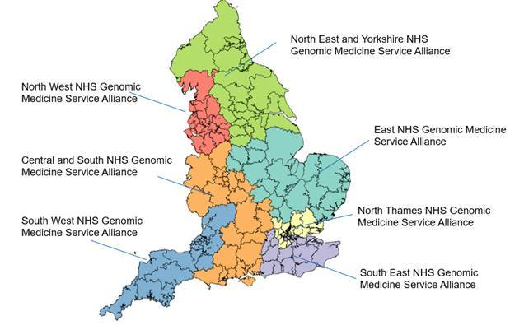

To request approval of your GMSA chief nurse, please contact the appropriate representative, as noted in the third and fourth columns.

|  |  |  |  |
| --- | --- | --- | --- |
| **GMSA** | **Chief nurse (for information only)** | **Please direct your request for approval to:** | **Contact details** |
| **Central and South** | Lisa Stalley-Green | Awaiting contact details. For enquiries, please contact [genomicseducation@hee.nhs.uk](mailto:genomicseducation@hee.nhs.uk). | |
| **East** | Lorraine Szeremeta;  Nancy Fontaine;  Carolyn Fox | Sam Hayto | [samantha.hayto @uhl-tr.nhs.uk](mailto:samantha.hayto@uhl-tr.nhs.uk) 0116 258 5488 |
| **North East** | Chris Morley | Awaiting contact details. For enquiries, please contact [genomicseducation@hee.nhs.uk](mailto:genomicseducation@hee.nhs.uk). | |
| **North Thames** | Natalie Percival | Awaiting contact details. For enquiries, please contact [genomicseducation@hee.nhs.uk](mailto:genomicseducation@hee.nhs.uk). | |
| **North West** | Janelle York | Awaiting contact details. For enquiries, please contact [genomicseducation@hee.nhs.uk](mailto:genomicseducation@hee.nhs.uk). | |
| **South East** | Avey Bhatia | Awaiting contact details. For enquiries, please contact [genomicseducation@hee.nhs.uk](mailto:genomicseducation@hee.nhs.uk). | |
| **South West** | Caroline Mills | Awaiting contact details. For enquiries, please contact [genomicseducation@hee.nhs.uk](mailto:genomicseducation@hee.nhs.uk). | |