**PRENATAL EXOMES TRAINING** **ACTIVITY**

# Table of Contents

Table of Contents 1

1. Introduction and course aims: 1

2. Learning outcomes: 1

3. Course format: 2

4. Assessment: 2

5. Pre-reading: 2

5.1 Prenatal genomics 2

5.2 Exome sequencing 2

5.3 ACGS UK best practice guidelines 2

6. Databases and other tools for variant interpretation evidence gathering 3

6.1 Gene and phenotype information 3

6.2 Population databases 5

6.3 Functional impact 5

6.4 Literature searches and other databases 6

6.5 A comprehensive suite: DECIPHER 7

# Introduction and course aims:

This course aims to introduce and discuss concepts from the [prenatal genomics module](https://curriculumlibrary.nshcs.org.uk/stp/module/S-G-S2/) and to support STP (Scientist Training Programme) trainees in achieving the learning outcomes of training activity 5 (“Analyse, interpret and report the results for cases referred for prenatal exome analysis”). The course is also aimed at healthcare professionals involved in the delivery of the National Genomics Test Directory fetal exomes service ([R21](https://www.genomicseducation.hee.nhs.uk/genotes/knowledge-hub/r21-rapid-prenatal-exome-sequencing/)), those accessing it for the patients they manage and those who require knowledge of the service for CPD and further training and development (e.g. HSTT trainees, RCPath exam).

# Learning outcomes:

Theoretical and practical concepts relevant to prenatal exome analysis in clinical practice will be covered in this course. Learners will gain an understanding of the patient journey from referral to reporting and will reflect on contemporary issues faced by healthcare professionals delivering and accessing the service for the benefit of their patients. By the end of this course, you will be able to:

* Apply appropriate testing strategies to patients referred following abnormal ultrasound scan findings.
* Interpret genomic variants, including copy number variants and investigate the clinical significance of variants using a range of bioinformatic tools, databases and datasets, in accordance with best practice guidelines.
* Interpret and report prenatal genomic findings, including appropriate recommendations for patient management.

# Course format:

Trainees will attend an online webinar on Friday, 27th September 2024 and an online workshop on Friday, 11th October 2024. Engagement with the training materials during independent study time is also expected.

Trainees might attend the Rapid prenatal exome sequencing service (R21) educational MDT on Wednesday, 2nd Oct 2024 12:30 PM - 2:00 PM. This is optional.

# Assessment:

Learners will complete formative assessment tasks during the course. Summative assessment for STP trainees will consist of case studies to test achievement of the learning outcomes. A certificate of completion will be made available and this must be uploaded to OneFile as evidence.

# Pre-reading:

The successful completion of this course requires knowledge and understanding of the following topics:

## Prenatal genomics

This overview introduces approaches to prenatal genomics testing (5 minutes read). Check the box after completing this reading activity.

<https://www.genomicseducation.hee.nhs.uk/blog/prenatal-genomics-an-overview/>

## Exome sequencing

Review the clinical applications and limitations of exome sequencing in this webpage (30 minutes read including viewing all links to additional pages and videos).

[Exome sequencing](https://www.genomicseducation.hee.nhs.uk/genotes/knowledge-hub/whole-exome-sequencing/)

## ACGS UK best practice guidelines

The interpretation of SNVs and CNVs is based on professional guidelines that are subject to constant updates, whilst underpinned by logical biological principles, such as variant rarity, supportive in silico predictions and segregation with disease, for example.

A brief overview of the guidelines is given in the following three videos:

Add links

Learners are encouraged to complete the Massive Open Online Course (MOOC) in Genetic Variation and ACMG guidelines, which can be accessed [here](https://www.futurelearn.com/courses/interpreting-genomic-variation-fundamental-principles). Knowledge of variant interpretation in cancer genes is not the focus of this course, but learners who wish to start gaining knowledge in this area at this stage, may access the MOOC on [Interpreting Genomic Variation: Inherited Cancer Susceptibility.](https://www.futurelearn.com/courses/interpreting-genomic-variation-inherited-cancer-susceptibility)

The latest version of the UK guidelines for interpretation of variants in rare disease is available [here](https://www.acgs.uk.com/media/12533/uk-practice-guidelines-for-variant-classification-v12-2024.pdf).

# Databases and other tools for variant interpretation evidence gathering

Assessing variants relies on collecting information on the gene, the phenotype, the genotype and the characteristics of the variant(s) under investigation. A vast suite of databases and datasets are useful in this process.

## 6.1 Gene and phenotype information

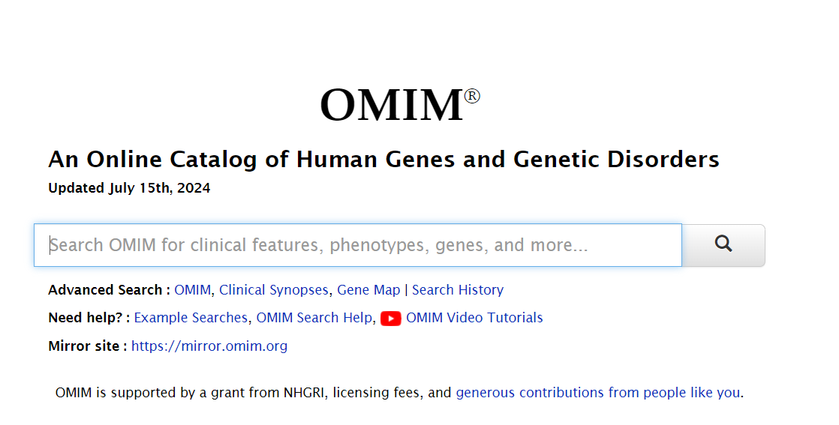

<https://www.omim.org/>

OMIM provides an online catalogue of human genes and genetic conditions. The clinical synopsis function (click on phenotype number after conducting a search by gene name) summarises the phenotypes described in the literature. The website provides details of gene function and a limited number of previously reported variants.

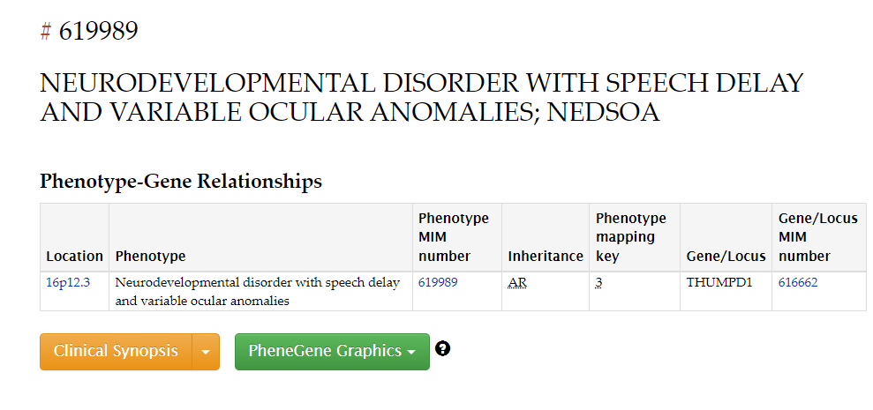

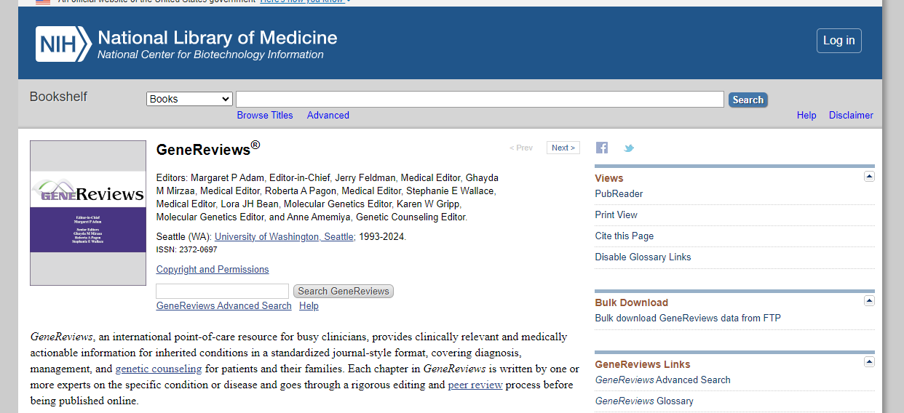

<https://www.ncbi.nlm.nih.gov/books/NBK1116/>

The GeneReviews database provides comprehensible descriptions of the clinical features of different disorders, differential diagnoses, testing approaches and types of variants reported.

## 6.2 Population databases

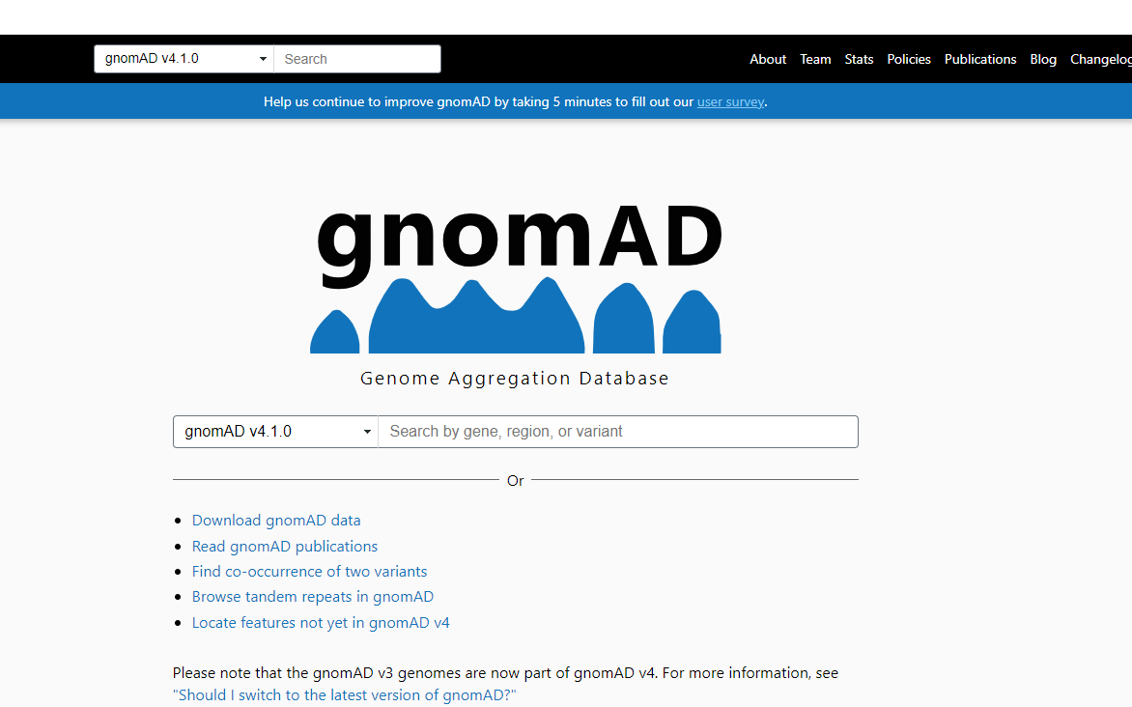

The Genome Aggregation Database ([gnomAD](https://gnomad.broadinstitute.org/)) is one of the most comprehensive resources for variants identified by whole exome or whole genome sequencing.

The v4.1 data set (GRCh38) includes 730,947 exome sequences and 76,215 whole-genome sequences from unrelated individuals, of diverse ancestries, sequenced as part of various disease-specific and population genetic studies. This dataset is considered a reliable proxy of normal populations, which should be interpreted as free of severe, early-onset pediatric disorders. The data does include cohorts with specific adult-onset conditions (e.g. cardiac and psychiatric) and a large contribution is now from the UK Biobank data.

Generally, a common variant with have a frequency of 5% in a population, and a rare variant will be below 1%. Cut-offs of 1 in 1,000 alleles, MAF=0.001 (1 in 500 individuals) and 1 in 10,000 alleles, MAF=0.0001 (1 in 5,000 individuals) are typically used for rare variants.

<https://gnomad.broadinstitute.org/>

For variants that are listed in gnomAD, when ascertaining pathogenicity, the number of acceptable alleles present will depend on the severity and prevalence of the condition, as well as its mode of inheritance and penetrance.

In addition to allele frequency data, for variants listed in gnomAD, information on in silico predictions and ClinVar submissions is provided in gnomAD.

## 6.3 Functional impact

[SpliceAI](https://spliceailookup.broadinstitute.org/) and [REVEL](https://sites.google.com/site/revelgenomics/downloads) are the recommended *in silico* predictors to assess impact on splicing and aminoacid changes, respectively. For variants listed in gnomAD, these predictions are usually available within the variant results page.

## 6.4 Literature searches and other databases

Variants should be evaluated in the context of the phenotype of the patient being tested by the clinical lab and also taking into account other cases with the same variant.

[HGMD](https://apps.ingenuity.com/ingsso/login) and [ClinVar](https://www.ncbi.nlm.nih.gov/clinvar/intro/) should be used to identify additional cases with the same variant.

Google and PubMed may also return additional results.

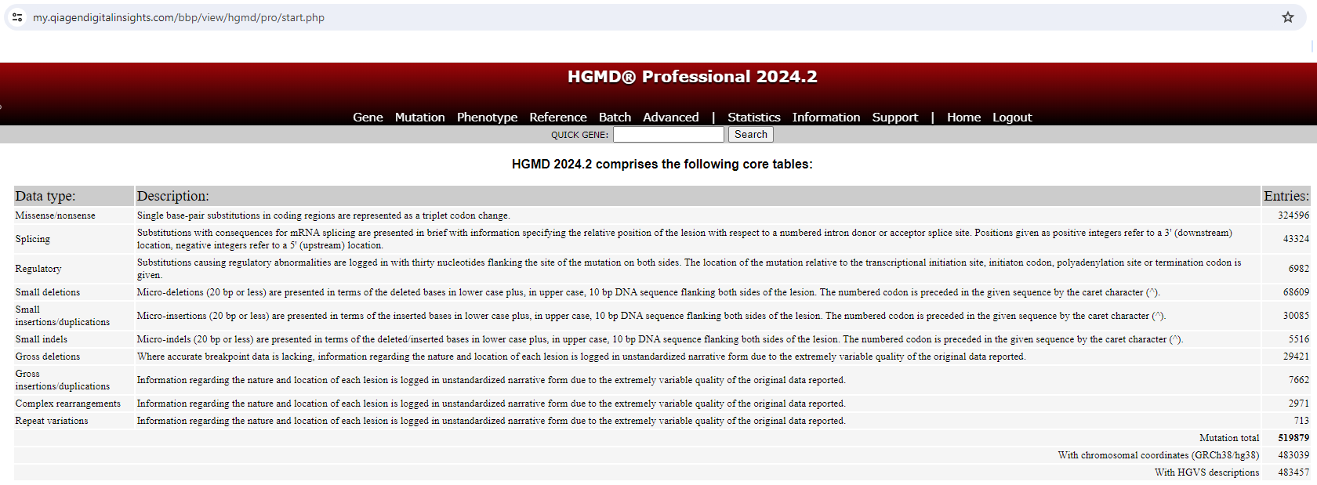

<https://apps.ingenuity.com/ingsso/login>

HGMD Professional list variants published in peer-reviewed publications. Access to HGMD is available via registration with a nhs.net e-mail account.

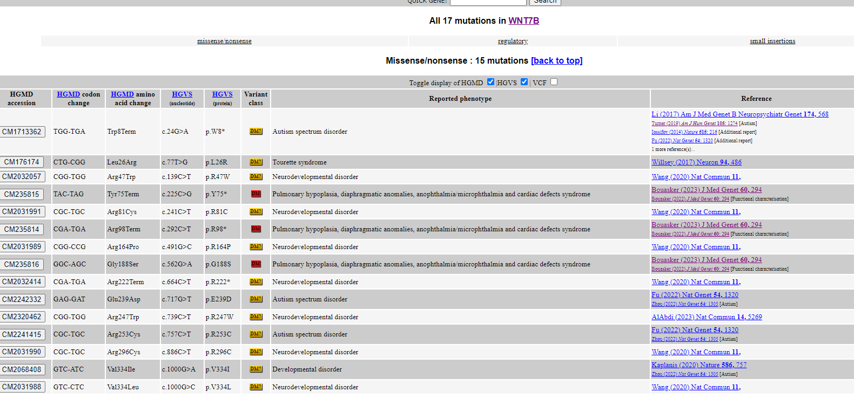

ClinVar ( is a repository of variants identified in clinical laboratories, but these have not been necessarily assessed by a competent clinical scientist and as such, an independent assessment of the variants should be conducted. Submitting laboratories might be contacted for additional information to aid variant assessment.

Unlike HGMD, ClinVar displays variants that are not published in the literature.

A Google search, usually via Alamut, may return additional results that are not in HGMD nor ClinVar (e.g. from poster presentations, PhD dissertations, etc).

[PubMed](https://www.ncbi.nlm.nih.gov/pubmed) is a comprehensive and up to date database of published literature. This is more commonly used to search gene-level and phenotype level information, rather than to search for a specific variant.

## 6.5 A comprehensive suite: DECIPHER

[DECIPHER](https://www.deciphergenomics.org/) contains a suite of resources for variant interpretation, allowing users to link out to datasets from OMIM, gnomAD, ClinVar and many other datasets. It is a recommended starting point for variant assessment.