Virtual reality resource supporting material: RiVR Link virtual reality headset system
User guide

Contents

Introduction

1.1 Purpose of this user guide

1.2 Health and safety instructions (read before use)

2.0 Overview

2.1 Overview of available assets

2.2 Modes of use

3.0 Cleaning, maintenance and storage

4.0 Preparing for a session

4.1 Booking a suitable room

4.2 Charging the equipment

4.3 Printing training resources

4.4 Accessing assessments for VR resources

5.0 Using the headsets

5.1 Powering on

5.2 Adjusting the volume

5.3 Adjusting the brightness

6.0 Using the RiVR Link laptop

7.0 Setting up for different VR modes

7.1 Synchronised mode

7.2 Remote mode

7.3 Kiosk mode

8.0 Completing a session

9.0 Further support

1.0 Introduction

1.1 Purpose of this user guide
This user guide outlines how to navigate and use the RiVR Link virtual reality (VR) headset system for training use. Each box will either contain eight headsets and a RiVR Link laptop or eight headsets.

There are eight videos, known as assets, that are available to watch. Each asset is accompanied by a supporting material document called a ‘trainer pack’ that contains information for educators, including appropriate places to pause the film (‘bookmarks’) for discussion and suggested pre- and post-session materials.

1.2 Health and safety instructions (read before use)
To minimise misuse of the equipment and for the health and safety of the learners, the following must be adhered to:
- Important: All headsets must be kept out of direct sunlight, as it will damage the lenses. Any damage caused by sunlight is not covered under warranty.
- Headsets must only be used under the supervision of a competent trainer and are not to be taken out of the department.
- Eating and drinking is not permitted while equipment is being used.
- Learners must be seated when using a VR headset.
- If learners feel nauseous or anxious at any point during the VR experience, they should remove their headset immediately and inform the trainer.
- Headsets must not be used in the learner has an eye infection.
- Care must be taken not to scratch or damage the lenses, or the cable on top of the headsets.

2.0 Overview

2.1 Overview of available assets
The eight assets are listed below with their associated runtimes [hh:mm:ss]:
- Massively parallel sequencing [00:33:22]
- Non-invasive prenatal diagnosis (NIPD) [00:33:07]
- Non-invasive prenatal testing (NIPT) [00:22:23]
- Multiplex ligation-dependent probe amplification (MLPA) [00:22:18]
- Nucleic acid extraction from FFPE tissue [00:19:59]
- Polymerase chain reaction (PCR) [00:06:45]
- Preparation of samples for cytogenetic analysis [00:19:59]
- SNP microarray [00:27:24]
Assets are stored physically on the laptop hard drive and headsets. Assets are also available in a standard video format (not virtual reality) for accessibility purposes only (for example, individuals requiring subtitles); if you have any learners who require access to these, the Genomics Education Programme team will require the learner’s personal email address to be able to grant them access.

2.2 Modes of use
The VR headsets can be used in three different modes: synchronised, remote or kiosk. Each mode is described below. For more detailed information on how to set up the equipment for each mode, see section 7.0.

Synchronised
In this mode, all headsets and the RiVR Link laptop are linked to the router within the RiVR Link box. All headsets view the same asset synchronously as navigated by the trainer who will operate the running of the asset using the RiVR Link laptop.

Remote
In this mode, all headsets and the RiVR Link laptop are connected to Wi-Fi and not to the router in the RiVR Link box. The trainer will select the ‘remote’ setting in the laptop which will provide a unique session code that can be inputted into each headset to enable access the remote session. The session can then be run from the laptop with the trainer selecting the required asset. The remote format allows synchronised training for VR headset users across the GLH without the need for physical proximity to the RiVR Link box and laptop.

Kiosk
In this mode, the headsets access assets independently. There is no need for the laptop and each learner can view whichever asset they wish.

3.0 Cleaning, maintenance and storage
Cleaning
Wipe each headset with antibacterial alcohol-free wet wipes after use. Please take care not to clean the lenses with the wipe. RiVR recommends not using alcohol wipes as this will cause deterioration of the lenses over time.

Maintenance
Perform a visible check to ensure there are no obvious signs of damage before returning the headsets to the RiVR Link box for storage.
Storage
The headsets are to be stored with the head adjustment turned fully to the right (smallest head circumference setting), switched off and placed in the RiVR Link box on top of the hand controllers. The headsets should be plugged in ready for charging for when they are next used. The RiVR Link laptop is to be stored within the RiVR Link box in the storage location provided.

4.0 Preparing for a session

4.1 Booking a suitable room
The VR headsets are only to be used in a suitable office environment where their use will not distract others from their work. The mode in which the headsets are to be used (See section 7.0) will influence the type of space booked for training and the time required for the session.
If a group-led, synchronous session is being held, it is recommended that a suitable room is booked with capacity for all attendees to sit comfortably and in close proximity to the RiVR Link box. The box does not need to be in the same room as the headsets, as long as it is nearby (for example, in the room next-door). Session time will depend on the number of trainees and their prior experience. As a guide, it is recommended that trainers allow approximately 40–45 minutes in addition to the duration of each video to have sufficient time to work through any supporting materials. If the headsets are to be used in kiosk mode, your GLH may have a booking system – please check with your practice educator.
Each headset can only be used by learners after a competent trainer has provided appropriate detail on how to use the headsets and has signposted learners to this user guide. The learners are responsible for following instructions in this guide and those provided by the trainer. The trainer is responsible for distributing and collecting each headset and ensuring the safe return of each to the RiVR Link box for charging.

4.2 Charging the equipment

Charging the headsets
Before running a session, it is necessary to charge all the headsets at least one hour prior to use. To charge the headsets, open the RiVR Link box and connect it to a power source using the plug and cabling provided within the box. When the headsets are charging, ensure that the box remains open. Alternatively, any USB-C cable can be used to charge the headsets individually.

Charging the RiVR Link laptop
For synchronised and remote sessions, ensure the laptop is charged using the enclosed cabling within the RiVR Link box.

4.3 Printing training resources
Training resources, as well as other useful information, can be found on this webpage: www.genomicseducation.hee.nhs.uk/about-us/gtac/virtual-reality-inside-the-lab/
Each resource is named ‘GTAC virtual reality resource supporting material: X’. Clicking the relevant link will provide access to view and download trainer pack and model answers documents for each asset.
The trainer pack contains information for the trainer to support their teaching, including recommended pre-session learning materials, learning objectives, bookmarks at which to stop the film (with questions and answers to help guide discussions) and links for learners to access post-course assessments and resources.
The model answers document includes the questions and answers from the trainer pack but in more detail, and is recommended to give to learners after a session as a reference, or used by those working through the resource in a self-led environment.

4.4 Accessing assessments for VR resources
The assessment for learners is described in the trainer packs but is physically hosted on the virtual learning environment (VLE). Trainers should direct learners (including self-led learners) to complete the relevant assessment after a session has been completed. To be able to access the assessments, learners will first need to register for a VLE account in advance. Account generation is not instantaneous, so it is recommended that this is planned for in any communication from trainers to learners ahead of running the session.
Guidance on accessing the VLE and enrolling:
The Learner Onboarding Policy can be found on the GTAC FutureNHS site: https://future.nhs.uk/GenomicsTrainingAcademy/view?objectId=225461701
The VLE can be accessed here: https://pgvle.co.uk/
- In the course categories section at the bottom of the home page, click on ‘Genomics Training Academy – GTAC’
- On this next page, click on ‘Laboratory’ to access the virtual reality assessments. Each assessment is titled ‘Virtual reality:....’
- Click on the ‘enrol me’ button. You will then be enrolled to take the assessment.

5.0 Using the headsets
Each headset has a unique identifier on the front of it which is named ‘NHS-GEP20XX’, where XX are unique numbers. Although headsets can be renamed, it is not recommended. Each headset as a sensor between the lenses. This is not a recording device and only activates when the headsets are being worn. Sensors must not be covered at any time. Headsets also have a display port which should not be used.
The headsets have a number of controls, outlined below.
5.1 Powering on
Switch on the headset by pressing the on/off switch on the top left. Press the button down until the blue light flashes on.

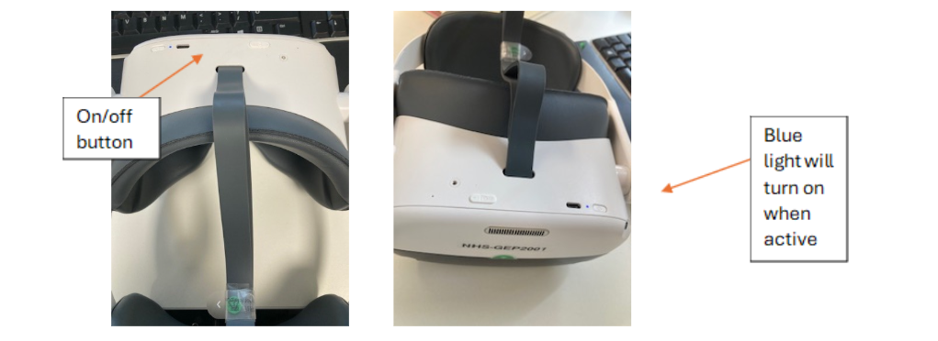
Once powered up, the headset should open on the home screen with a view of the earth, a tree, a sofa and bookcase. If the control panel menu is not visible, it can be displayed by using the bottom circle button on the right side of the headset. The larger button above this is the selection button – pressing this enables you to make a selection, like the left click button on a computer mouse.
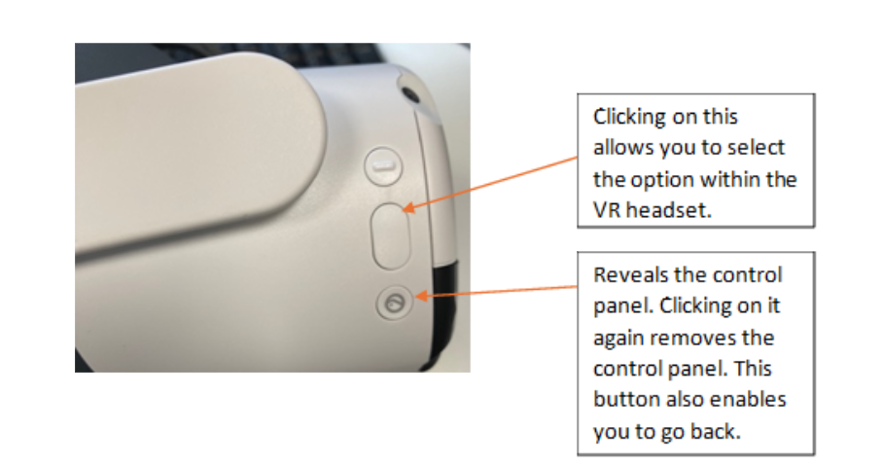
To open the RiVR link lecture theatre, click on ‘Library’ and the black RiVR Link button.

5.2 Adjusting the volume
Volume control is located on the bottom of the VR headset. Speakers are located on both sides of the headset and will be activated automatically, unless headphones are plugged in.
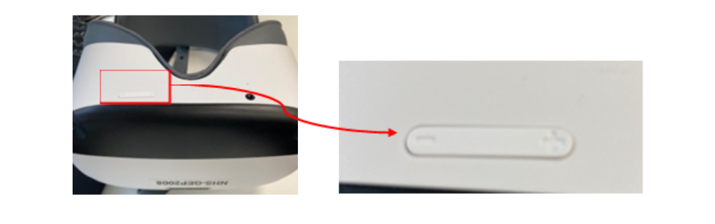

5.3 Adjusting the brightness
- Press on the control panel button on the right of the headset and then click on the settings icon.
- Click on the display menu and then adjust brightness to the required level.
- To exit the menu, press the control panel button on the right of the headset.
Note: It is important that you do not record or delete any content during the session. At the end of the session, make sure all headsets are turned off, folded up and placed back in the RiVR Link box.

6.0 Using the RiVR Link laptop
The RiVR Link laptop is a touch screen device loaded with the RiVR Link software and is stored within the RiVR Link box. The charge cable for the laptop is also stored within the box within the cable storage section. The laptop is required for synchronised and remote sessions.
Please note: the box must be switched on for five minutes prior to starting up the laptop and headsets to enable the box router to start and be available for selection when linking the laptop.
On opening the laptop, you will see the following screen:

Click on the mouse to view the RiVR Link ‘password’ screen.
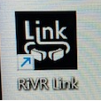
Input the laptop and router password. These can be found by accessing the information through the QR code on the left of the screen. The QR code will also give you access to the GLH that the VR kit has been allocated to, the kit asset tag, the RiVR Link License Key, the box model (RiVR Fusion 8 (Pico Neo 3 Pro) 2024 and the manual.
To open the required software for the VR session, click on the RiVR link icon on the desktop or in the control panel at the bottom of the screen:

You will now see the RiVR link interface below:
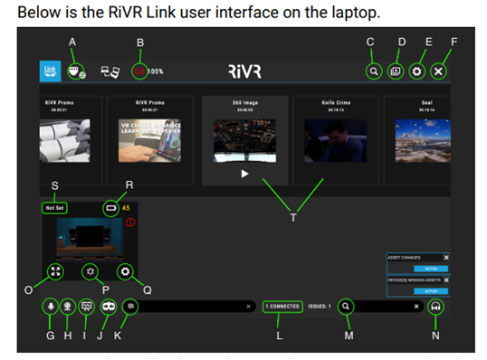
A. Wifi: Check that the laptop is connected to the router inside the kit.
B. Laptop battery percentage: View how much charge the laptop battery has.
C. Search: Search for assets by name.
D. Library: Manage and sync assets.
E. Settings: Customise the RiVR Link experience.
F. Close: Close RiVR Link and finish the session.
G. Microphone: Talk directly to all learners via their headsets.
H. Webcam: Show the laptop’s webcam inside the headsets for learners.
I. Whiteboard: Draw on a virtual whiteboard, visible to learners.
J. Re-centre: Orient all headsets to ‘north’, to face forwards.
K. Text box: Send a message to the virtual lecture theatre.
L. Connections: View how many devices are connected to the RiVR Link session.
M. Search headsets: Search for a specific device within the session by name.
N. Headset volume: Set the volume for all headsets.
O. Headset view: See one device’s view in full-screen
P. Bell/ping: Play a sound on a headset – useful to identify a problem device.
Q. Headset setting: Rename devices remotely.
R. Headset battery percentage: View remaining battery of a headset.
S. Device name: View unique device name.
T. Assets: Navigate through a list of all available assets by swiping and press to play.
The view from each connected headset will appear in the bottom half of the screen. Click on the headset view furthest to the right to scroll through each view, or use the touch screen on the laptop to scroll. Trainers can use their webcam and write messages at any point during the session. If the headsets are pointing down, the trainer cannot re-orientate them, but they can play an alarm noise to catch a learner’s attention.
Before starting a session, make sure that the right number of headsets are connected. “Play” should only be pressed when all required headsets are on, or some will go out of sync.

7.0 Setting up for different VR modes
The headsets can be used in synchronised, remote or kiosk mode. Below are instructions on how to set up the laptop and headsets for each mode.
7.1 Synchronised mode
The laptop
After opening the laptop, ensure that the internet setting is linked to: NHS-GEPxxxx_Fast (the xxxx will be kit specific numbers) as this is the connection to the box router.
The VR headset
Within each VR headset, ensure the internet setting is set to NHS-GEPxxxx_Fast to ensure connection to the RiVR Link box router.
The RiVR Link box router
Ensure that the box is plugged into a power source, switched on and that the modem aerials are in an upright position. The box does not need to be in the same room as the headsets, as long as it is nearby, for example, in the room next door.

7.2 Remote mode
This mode requires all the headsets to be used in the session and for the laptop to be connected to the internet by a Wi-Fi connection (not to the box router). The Wi-Fi connection used will depend on availability, for example, nhswifi. The Wi-Fi connection does not have to be the same for each headset – learners could use their mobile phones, for example. It is recommended that there is a MS Teams call set up for a remote session to allow communication between the trainer and the learners in their locations.
The laptop
Connect the laptop to the internet from the start page. Click in the bottom right hand corner of the screen (see 1. below) and select an appropriate wifi connection (see 2. below):
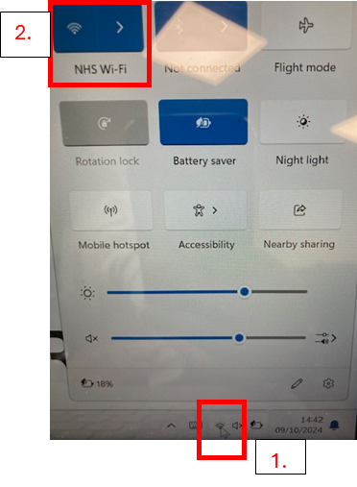
Check that you have a Wi-Fi connection by opening the RiVR link interface and checking that there is a globe symbol in the top left hand corner.
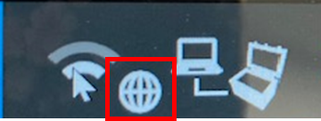
From the ‘Remote options’ menu, toggle on the Remote Mode option. A box will open providing a session code. Write this session code down as this will be required for remote learners to enter the session.
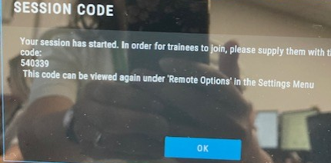
The code is unique to each session and will need to be generated prior to starting each remote session.
Give the session code to the users of the remote VR headsets as they will need to input this code within their VR headset in order access the remote session.
The VR headsets
Connect each VR headset to the internet. Click the menu button on the right of the VR headset and click on ‘quick settings’ which is where the time is displayed in the control panel.
Click on the WLAN menu and choose the Wi-Fi network to connect to. The menu is navigated by using the click button and scrolling up or down the menu with your head motion. To check that you have internet access, try opening YouTube in the pico browser menu. It has been noticed that with some nhswifi, if the time and date within the browser are incorrect, the VR headset will not connect to the internet. If you find this to be the case, the time and date within the browser window need to manually changed.
Click on the RiVR link icon and within the lecture theatre, select the settings button at the top right-hand corner of the main lecture theatre screen.
Select the connection menu and toggle Remote Mode to ‘on’. A number panel will appear requesting the remote session code. This should be provided by the trainer and is unique to each session.
The session will commence when the trainer begins the video/commences the session.

7.3 Kiosk mode
This mode allows asynchronous learning that allows the learner to access the video assets independently within the VR headset and play them at their own pace. No Wi-Fi connection is required for this mode. To switch this mode on, follow these steps:
- Within the VR headset in the RiVR lecture theatre interface (see section 6), select settings.
- Select kiosk mode.
- The videos will appear and the learner can choose which video to play and select it using the buttons on the right of the headset.
- To pause, press the middle button on the right of the headset. On-screen options appear and you are able to either pause or stop the asset.
- To return back to the home screen, press the top button on the right of the headset and follow the prompts.
Please note: bookmarks cannot be used in kiosk mode.

8.0 Completing a session
The headsets should be taken back to the home screen using the bottom button and following the prompts.
Turn off on the top of the headset – hold the button down until the blue light stops flashing and goes off.
Wipe the headset – avoiding the front and lenses with non-alcohol based wipes.
Replace the headsets back in the storage box in the correct orientation.
Plug into the box ready for the next use.

9.0 Further support
RiVR can be contacted for support by email: help@rivr.uk or call +44 1926 800740. See also the RiVR manual which is linked to this user guide (6.0 Using the RiVR Link laptop).

